* **Name of the Activity:** One Day State Level Seminar on PF Management, Tax Assessment and Planning
* **Date of the Activity**: 15.02.2023
* **Speakers:**
  + Dr. Subrata Mukherjee, Associate Professor, Mahadevananda Mahavidyalaya.
  + Mr. Santunu Ganguly, Software Developer.
* **Organizing Department:** PF subcommittee, Chakdaha College
* **Number of Participants:** 36
* **Outcome:** A One Day State Level Seminar on "PF Management, Tax Assessment and Planning" was organised by PF Sub-Committee of Chakdaha College on 15 February, 2023. Dr. Swagata DasMohanta, honourable Principal of Chakdaha College was the patron and chairperson in the said seminar. The welcome address was delivered by her. Seminar coordinated by Dr. Nikhil Kumar Mondal, Associate Professor and Head, Department of Economics, Chakdaha College. Dr. Subrata Mukherjee, Associate Professor of Mahadevananda Mahavidyalaya and Mr. Santanu Ganguly, Software Developer, were chief guests and eminent speakers in the seminar. Their valuable talk on Tax Assessment and Planning, and PF Management was able to draw and hold the attention of the listeners throughout the programme. The listeners have been largely benefitted by the talk as this talk is going to help in taking important decisions regarding PF management and tax planning. The vote of the thanks in the seminar was delivered by Dr. Sarbajit Paul, Associate Professor and Head, Department of Commerce, Chakdaha College and joint convenor of the seminar.
* 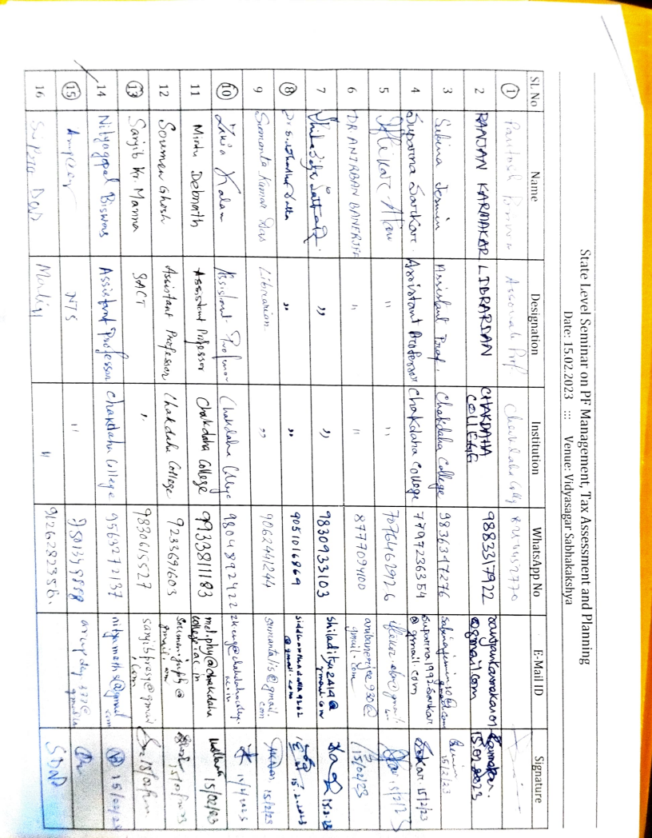**Attendance:**

